Circulatory System Terminology
Blood
Plasma: _________________________________________________________ ________________________________________________________________
Red blood cells: ___________________________________________________ ________________________________________________________________
White blood cells: _________________________________________________ ________________________________________________________________
Platelets: ________________________________________________________ ________________________________________________________________
Oxygenated: _____________________________________________________ ________________________________________________________________
Deoxygenated: ___________________________________________________ ________________________________________________________________
Blood Vessels
Arteries: Blood vessels that carry blood away from the heart
Veins: Blood vessels that carry blood towards the heart
Capillaries: Blood vessels that are one-cell thick that carry blood to the body cells
Valves: Flap-like folds that prevent that backflow of blood. The make sure the blood flows in one direction
Lumen: Holes in blood vessels through which blood flows

- Identify the following blood vessels.
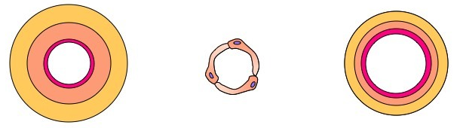
_______________ ________________ _______________
- In the box provided, draw the side on view for each blood vessel.
Draw valves in the blood vessel(s) that contain valves.

- Compare the size of the lumen for each blood vessel.
The lumen of the arteries are _____________________________________________ _______________________________________________________________________________________________________________________________________________________________________________________________________________

